ACMC-BASED HYBRID AC/LVDC MICRO-GRID
ABSTRACT
This study proposes the detailed modelling of a novel automatic centralised micro-grid controller (ACMC)-based hybrid AC/low-voltage DC (LVDC) micro-grid network, capable of off-grid and on-grid operation of the system with a coordinated control. The micro-grid is designed to work majorly with renewable power sources. This hybrid micro-grid is capable of interconnecting very large AC and LVDC networks, using a bi-directional AC/DC/AC converter. The AC and the LVDC networks consist of different feeders with loads connected at various voltages. The ACMC design proposed is responsible for controlling the real(P) and reactive(Q) power from the sources based on load requirement and voltage control of the LVDC network. It enables the system to have a plug and play feature. The proposed ACMC has been implemented on a test system consisting of AC and LVDC radial distribution networks designed, with a bi-directional converter. A doubly fed induction generator-based wind turbine and solar photovoltaic array with maximum power point tracking have been used as the sources. The system has been simulated in Simulink. The results show the ACMC successfully performs the four quadrant operation of P,Q in the system for various system conditions.

BLOCK DIAGRAM FOR PROPOSED SYSTEM

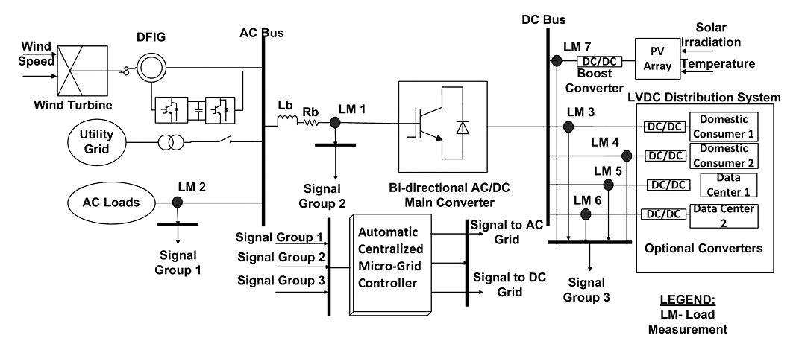
Fig. 1. Schematic representation of the proposed hybrid grid
DESIGNG SOFTWARE AND TOOLS:
MAT LAB /SIMULATION Software and simu power systems tools are used. Mainly control system tools, power electronics and electrical elements tools are used.

